homework_problem_set_1

JP

8/26/2021

1. What type of distribution is below?

**Answer:**

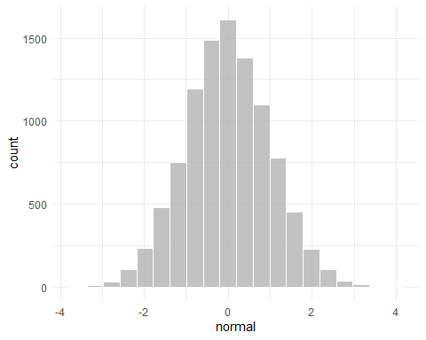

1. What type of distribution is below?

**Answer:**

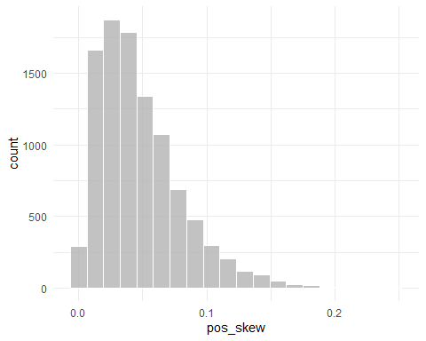

1. What type of distribution is below?

**Answer:**

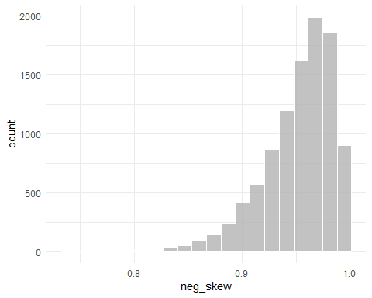

1. Describe what a bimodal distribution is in your own words.

**Answer:**

1. What is the term for the formula below?

**Answer:**

$$=\frac{f}{N}$$

1. What is the difference between a histogram and a bar graph?

**Answer:**

1. What is this term and what does it mean?

**Answer:**

$$Σ$$

1. What measure of central tendency is best for skewed data?

**Answer:**

1. What is xbar and what is mu

**Answer:**

$$μ$$

# Copy the code below from set.seed to N = 30

### Make sure to run everything together by highlighting everything and then pressing ctrl+R or command+R

# copy and paste this into your R  
  
set.seed(082421)  
categories = rep(letters[1:5], times = c(5, 3, 2, 8, 12))  
test_scores = rnorm(n = 30, mean = 4.21, sd = 1.16)  
  
categories = as.factor(categories)  
  
N = 30  
  
# If doing it by hand, the test scores are below  
test_scores

Test Scores:

**2.736386 2.275197 3.914406 3.832424 1.438419 4.248828 7.135805 4.573231  
3.048463 3.834346 2.795695 5.414713 5.043057 4.601812 5.427571 4.800366  
3.643789 5.168277 5.126070 6.255702 2.291076 4.038750 6.849778 4.289894  
6.104763 4.601148 4.167243 2.675319 3.541787 3.419616**

Categories:

**a a a a a b b b c c d d d d d d d d e e e e e e e e e e e e**

1. Provide the frequencies/proportions of categories A, B, C, D, & E
2. Calculate the cumulative frequency of categories D & E
3. Provide the mode for the categories.
4. Calculate the Median for the test scores.
5. Calculate the Mean for the test scores.
6. Calculate the deviation of scores from the mean score/value.

### Remember to double check your work with the following functions

mean(test_scores)

median(test_scores)